ASCII Shader

Version 1

Author: Daniel Carvalho Marques

This package focuses on creating an ASCII shader.

SampleScene contains an ASCII Shader that divides the screen up into small squares and then fills the squares with ASCII art.

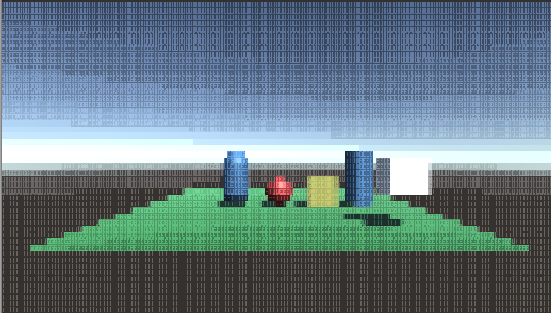

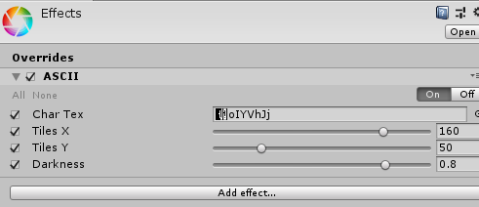

This shader requires a texture file with each of the characters using varying degrees of brightness as the shader uses the value of the brightness to place the characters in specific areas of the scene.

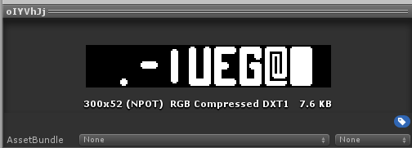

The camera in the scene requires a post process layer, a post process volume & the unity post processing package (version 2.1.4) to function.

